# Client Secure Class

Methods and properties described in this section are specific to ESP8266. They are not covered in [Arduino WiFi library](https://www.arduino.cc/en/Reference/WiFi) documentation. Before they are fully documented please refer to information below.

## Supported crypto

In the background the library [axtls](http://axtls.sourceforge.net/) is used. The library supports only rsa certificates and no new eliptic curve certificates. TLSv1.2 is supported since SDK 2.4.0-rc1.

The following ciphers and digests are supported by [specification](http://axtls.sourceforge.net/specifications.htm):

* **Symmetric Ciphers**
  + AES128-SHA
  + AES256-SHA
  + AES128-SHA256
  + AES256-SHA256
* **Asymmetric Ciphers**
  + RSA 512/1024/2048/4096 bit encryption/decryption.
  + RSA signing/verification
* **Digests**
  + SHA1
  + MD5
  + SHA256/384/512
  + HMAC-SHA1
  + HMAC-MD5
  + HMAC-SHA256

## loadCertificate

Load client certificate from file system.

loadCertificate(file)

Declarations

*#include <FS.h>*

*#include <ESP8266WiFi.h>*

*#include <WiFiClientSecure.h>*

const char**\*** certyficateFile **=** "/client.cer";

setup() or loop()

if (!SPIFFS.begin())

{

Serial.println("Failed to mount the file system");

return;

}

Serial.printf("Opening %s", certyficateFile);

File crtFile = SPIFFS.open(certyficateFile, "r");

if (!crtFile)

{

Serial.println(" Failed!");

}

WiFiClientSecure client;

Serial.print("Loading %s", certyficateFile);

if (!client.loadCertificate(crtFile))

{

Serial.println(" Failed!");

}

// proceed with connecting of client to the host

## setCertificate

Load client certificate from C array.

setCertificate (array, size)

For a practical example please check [this interesting blog](https://nofurtherquestions.wordpress.com/2016/03/14/making-an-esp8266-web-accessible/).

## Other Function Calls

bool verify (const char **\***fingerprint, const char **\***domain_name)

void setPrivateKey (const uint8_t **\***pk, size_t size)

bool loadCertificate (Stream **&**stream, size_t size)

bool loadPrivateKey (Stream **&**stream, size_t size)

template**<**typename TFile **>** bool loadPrivateKey (TFile **&**file)

Documentation for the above functions is not yet prepared.

For code samples please refer to separate section with [examples](http://arduino-esp8266.readthedocs.io/en/2.4.0/esp8266wifi/client-secure-examples.md) dedicated specifically to the Client Secure Class.

**EXAMPLES**

# Client Secure

The client secure is a [client](http://arduino-esp8266.readthedocs.io/en/2.4.0/esp8266wifi/client-secure-examples.html#client) but secure. Application example below will be easier to follow if you check similar and simpler [example](http://arduino-esp8266.readthedocs.io/en/2.4.0/esp8266wifi/client-examples.md) for the “ordinary” client. That being said we will concentrate on discussing the code that is specific to the client secure.

## Introduction

In this example we will be retrieving information from a secure server [https://api.github.com](https://api.github.com/). This server is set up in place to provide specific and structured information on [GitHub](https://github.com/)repositories. For instance, we may ask it to provide us the build status or the latest version of [esp8266 / Adruino](https://github.com/esp8266/Arduino/) core.

The build status of esp8266 / Adruino may be checked on the repository’s [home page](https://github.com/esp8266/Arduino#using-git-version) or on [Travis CI](https://travis-ci.org/esp8266/Arduino) site as below:

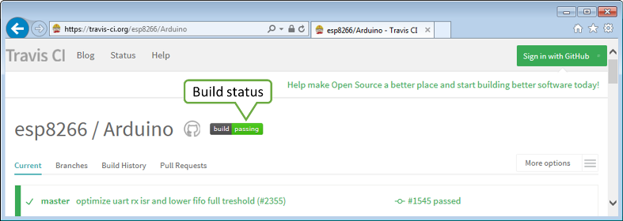

*alt text*

GitHub provides a separate server with [API](https://developer.github.com/v3/) to access such information is structured form as [JSON](https://en.wikipedia.org/wiki/JSON).

As you may guess we will use the client secure to contact [https://api.github.com](https://api.github.com/) server and request the [build status](https://developer.github.com/v3/repos/statuses/#get-the-combined-status-for-a-specific-ref). If we open specific resource provided in the API with a web browser, the following should show up:

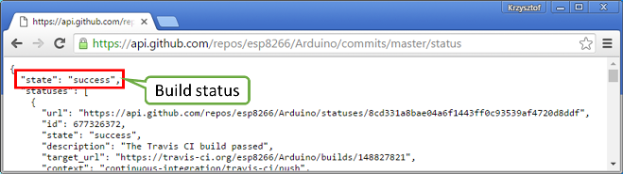

*alt text*

What we need to do, is to use client secure to connect to https://api.github.com, to GET /repos/esp8266/Arduino/commits/master/status, search for the line "state": "success" and display “Build Successful” if we find it, or “Build Failed” if otherwise.

## The Sketch

A classic [sketch](https://github.com/esp8266/Arduino/blob/master/libraries/ESP8266WiFi/examples/HTTPSRequest/HTTPSRequest.ino) that is doing what we need is already available among [examples](https://github.com/esp8266/Arduino/tree/master/libraries/ESP8266WiFi/examples) of ESP8266WiFi library. Please open it to go through it step by step.

## How to Verify Server’s Identity?

To establish a secure connection with a server we need to verify server’s identity. Clients that run on “regular” computers do it by comparing server’s certificate with locally stored list of trusted root certificates. Such certificates take several hundreds of KB, so it is not a good option for an ESP module. As an alternative we can use much smaller SHA1 fingerprint of specific certificate.

In declaration section of code we provide the name of hostand the corresponding fingerprint.

const char**\*** host **=** "api.github.com";

const char**\*** fingerprint **=** "CF 05 98 89 CA FF 8E D8 5E 5C E0 C2 E4 F7 E6 C3 C7 50 DD 5C";

## Get the Fingerprint

We can obtain the fingerprint for specific host using a web browser. For instance on Chrome press Ctrl+Shift+I and go to Security > View Certificate > Details > Thumbprint. This will show a window like below where you can copy the fingerprint and paste it into sketch.

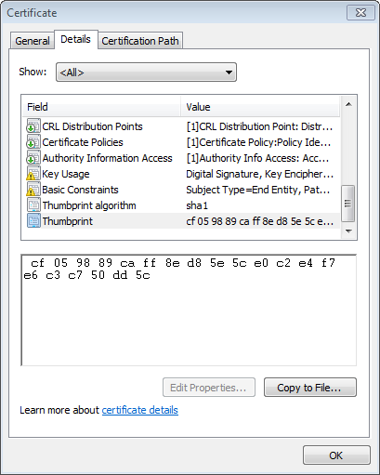

*alt text*

Remaining steps look almost identical as for the [non-secure client example](http://arduino-esp8266.readthedocs.io/en/2.4.0/esp8266wifi/client-examples.md).

## Connect to the Server

Instantiate the WiFiClientSecure object and establish a connection (please note we need to use specific httpsPort for secure connections):

WiFiClientSecure client;

Serial.print("connecting to ");

Serial.println(host);

if (!client.connect(host, httpsPort)) {

Serial.println("connection failed");

return;

}

## Is it THAT Server?

Now verify if the fingerprint we have matches this one provided by the server:

**if** (client**.**verify(fingerprint, host)) {

Serial**.**println("certificate matches");

} **else** {

Serial**.**println("certificate doesn't match");

}

If this check fails, it is up to you to decide if to proceed further or abort connection. Also note that certificates have specific validity period. Therefore the fingerprint of certificate we have checked today, will certainly be invalid some time later.

## GET Response from the Server

In the next steps we should execute GET command. This is done is similar way as discussed in [non-secure client example](http://arduino-esp8266.readthedocs.io/en/2.4.0/esp8266wifi/client-examples.md).

client**.**print(String("GET ") **+** url **+** " HTTP/1.1\r\n" **+**

"Host: " **+** host **+** "\r\n" **+**

"User-Agent: BuildFailureDetectorESP8266\r\n" **+**

"Connection: close\r\n\r\n");

After sending the request we should wait for a reply and then process received information.

Out of received replay we can skip response header. This can be done by reading until an empty line "\r" that marks the end of the header:

**while** (client**.**connected()) {

String line **=** client**.**readStringUntil('\n');

**if** (line **==** "\r") {

Serial**.**println("headers received");

**break**;

}

}

## Read and Check the Response

Finally we should read JSON provided by server and check if it contains {"state": "success":

String line **=** client**.**readStringUntil('\n');

**if** (line**.**startsWith("{\"state\":\"success\"")) {

Serial**.**println("esp8266/Arduino CI successfull!");

} **else** {

Serial**.**println("esp8266/Arduino CI has failed");

}

## Does it Work?

Now once you know how it should work, get the [sketch](https://github.com/esp8266/Arduino/blob/master/libraries/ESP8266WiFi/examples/HTTPSRequest/HTTPSRequest.ino). Update credentials to your Wi-Fi network. Check the current fingerprint of api.github.com and update it if required. Then upload sketch and open a serial monitor.

If everything is fine (including build status of esp8266 / Arduino) you should see message as below:

connecting to sensor-net

........

WiFi connected

IP address:

192.168.1.104

connecting to api.github.com

certificate matches

requesting URL: /repos/esp8266/Arduino/commits/master/status

request sent

headers received

esp8266/Arduino CI successfull!

reply was:

==========

{"state":"success","statuses":[{"url":"https://api.github.com/repos/esp8266/Arduino/statuses/8cd331a8bae04a6f1443ff0c93539af4720d8ddf","id":677326372,"state":"success","description":"The Travis CI build passed","target_url":"https://travis-ci.org/esp8266/Arduino/builds/148827821","context":"continuous-integration/travis-ci/push","created_at":"2016-08-01T09:54:38Z","updated_at":"2016-08-01T09:54:38Z"},{"url":"https://api.github.com/repos/esp8266/Arduino/statuses/8cd331a8bae04a6f1443ff0c93539af4720d8ddf","id":677333081,"state":"success","description":"27.62% (+0.00%) compared to 0718188","target_url":"https://codecov.io/gh/esp8266/Arduino/commit/8cd331a8bae04a6f1443ff0c93539af4720d8ddf","context":"codecov/project","created_at":"2016-08-01T09:59:05Z","updated_at":"2016-08-01T09:59:05Z"},

(...)

==========

closing connection

## Conclusion

Programming a secure client is almost identical as programming a non-secure client. The difference gets down to one extra step to verify server’s identity. Keep in mind limitations due to heavy memory usage that depends on the strength of the key used by the server and whether server is willing to negotiate the [TLS buffer size](https://www.igvita.com/2013/10/24/optimizing-tls-record-size-and-buffering-latency/).

For the list of functions provided to manage secure clients, please refer to the [Client Secure Class :arrow_right:](http://arduino-esp8266.readthedocs.io/en/2.4.0/esp8266wifi/client-secure-class.rst)documentation.